**Ex.No.8 Date :**

**CASE STUDY: LIBRARY MANAGEMENT SYSTEM**

**a) Aim:** Develop high level sequence diagrams for usecase



**b) Aim:** Identify MVC Classes:

**View Model Controller**

ILibrarian Member Record Book

Transaction Journals

Bill Magazines

Study Books

**c) Aim:** Develop Communication Diagram:



**d) Aim:** GRASP Patterns and their Responsibilities:

Book

Member Record

**Requests**

Member Record/Members requests for book and also responsibility assigned for Book i.e., information expert, patterns.

Creates

Transaction

Librarian

Librarian creates transaction and also responsibility assigned for transaction i.e., Creator, information expert, patterns.

e) **Aim:** Developing three layer package diagram for library management system

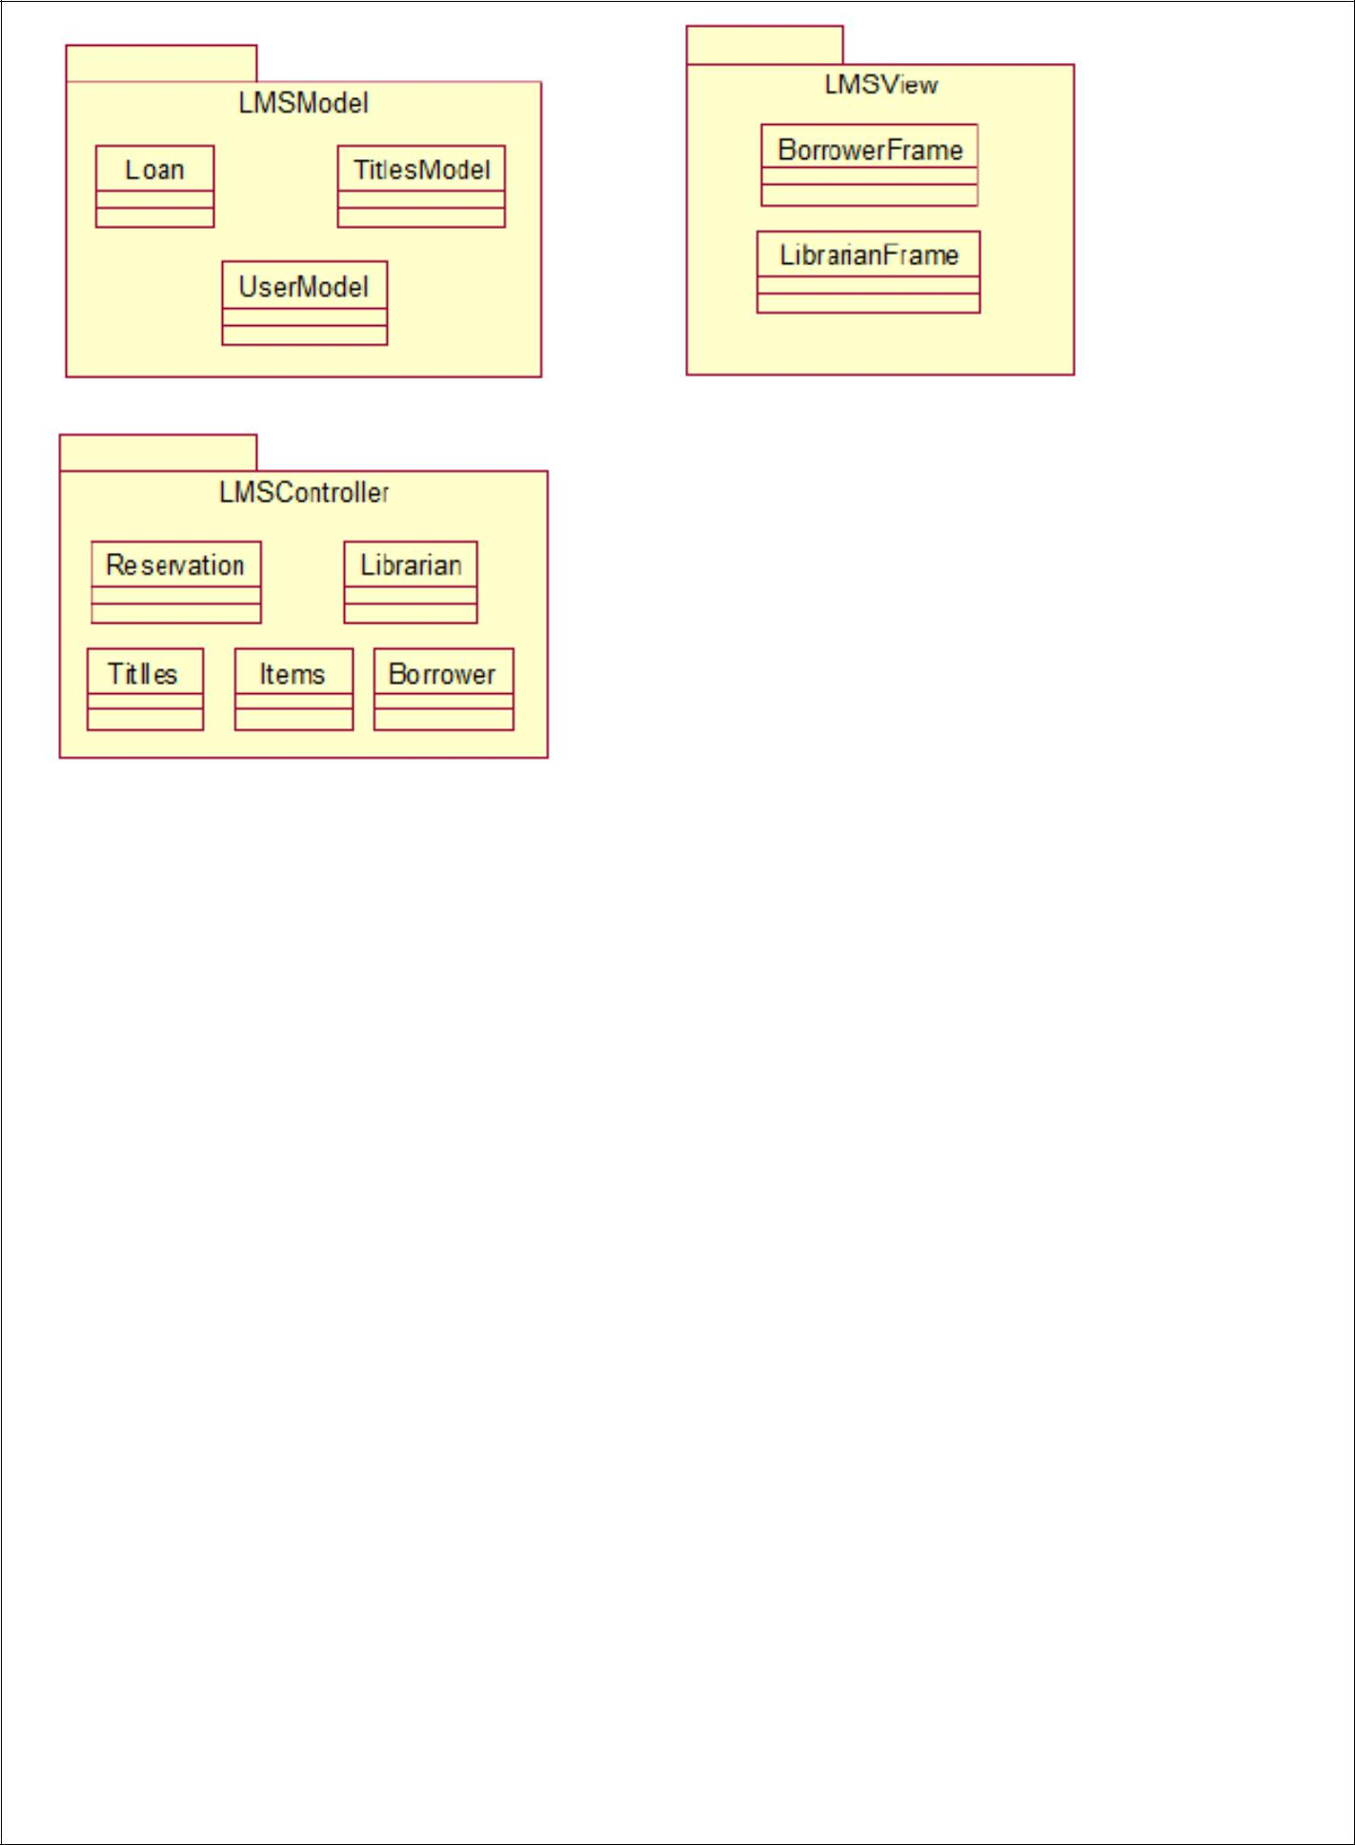

**Result:** The Design was successfully completed.